**TUGAS TEORI PERTEMUAN 2**

**DASAR PEMROGRAMAN**

**IMPLEMENTASI VISUAL CONTROL SYSTEM (GITHUB)**

**DAN KANBAN BOARD (NOTION)**



**Oleh :**

**Yefta Octavianus Santo            2341720110**

**PROGRAM STUDI D-IV TEKNIK INFORMATIKA**

**JURUSAN TEKNOLOGI INFORMASI**

**POLITEKNIK NEGERI MALANG**

**SEPTEMBER 2023**

1. **Mencari 5 repository dengan contributors, commits, dan star terbanyak**

* Python (1000 Contributors, 2924 Commits, Star 168k)

<https://github.com/TheAlgorithms/Python>

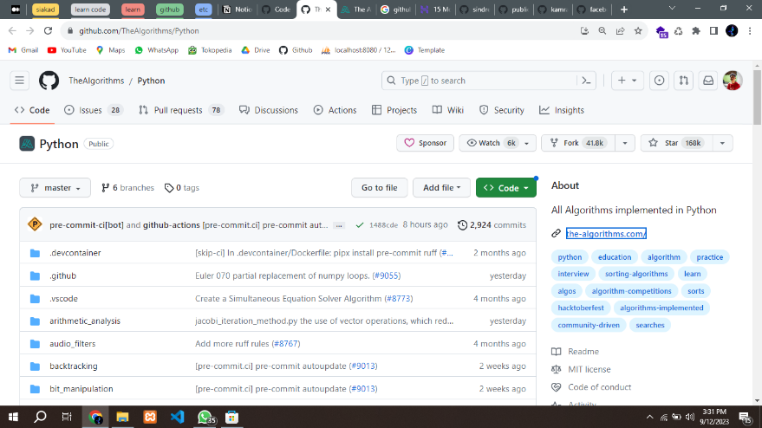

* Awesome-go (1753 Contributors, 4604 Commits, Star 108k)

https://github.com/avelino/awesome-go

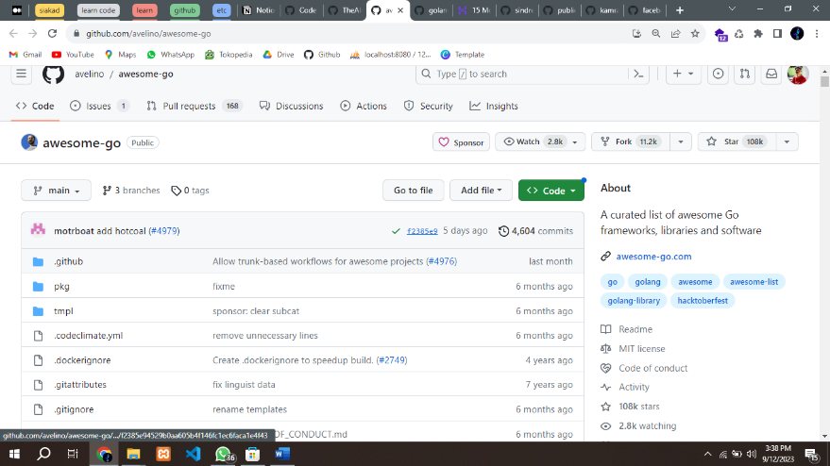

* golang-go (2016 Contributors, 57924 Commits, Star 114k)

<https://github.com/golang/go>

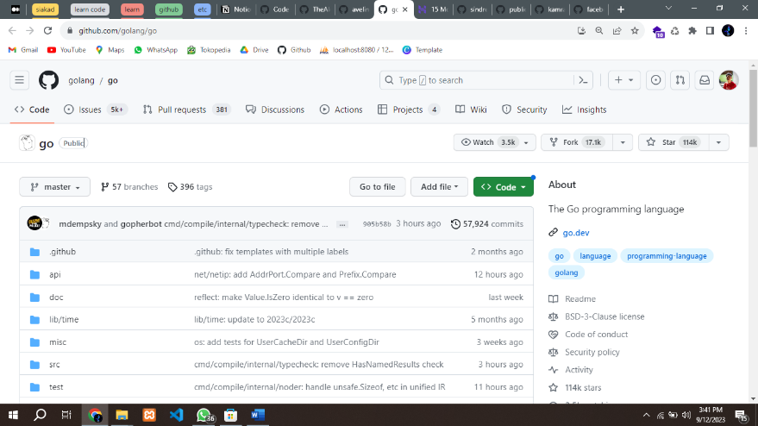

* Public-apis (1262 Contributors, 4527 Commits, Star 256k)

<https://github.com/public-apis/public-apis>

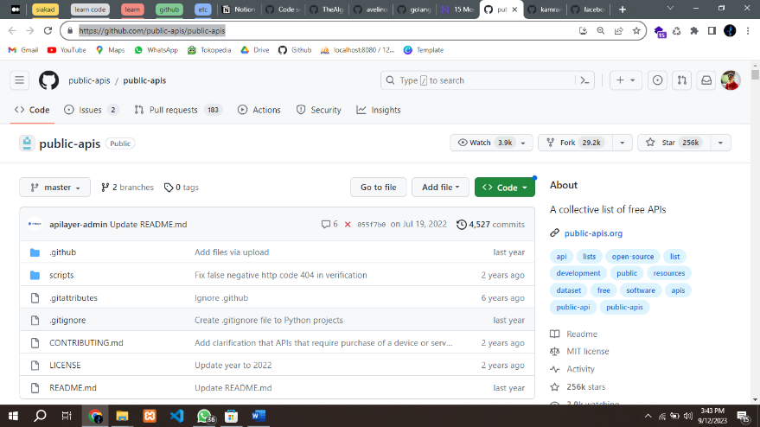

* Developer-roadmap (665 Contributors, 3684 Commits, Star 251k)

<https://github.com/kamranahmedse/developer-roadmap>



1. **Membuat daily activity pada kanban board selama sebulan**

Menggunakan aplikasi Notion

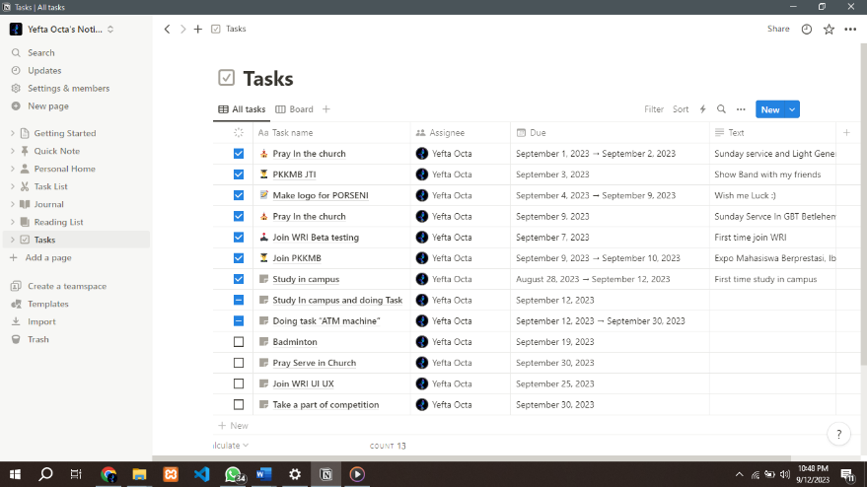

Keterangan :

✅ Done

➖ Doing

🔲 To Do